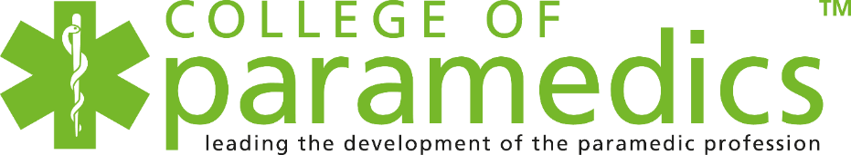

**INTERNATIONAL PARAMEDICS DAY SHINES SPOTLIGHT ON ‘UNSUNG HEROES’**

**June 11, 2024**

[**International Paramedics Day**](https://www.internationalparamedicsday.com/#:~:text=Launched%20in%202022%2C%20International%20Paramedics,modern%2Dday%20ambulance%20services'.) – hosted by the UK’s[**College of Paramedics**](https://collegeofparamedics.co.uk/) to honour the dedication and impact of paramedics, first responders and community volunteers around the world – will be held on July 8.

This year, the College of Paramedics is joining forces with more than 100 global paramedic associations, higher education institutions and affiliated organisations to celebrate and promote the campaign theme, “The Difference We Make” which will look at the many ways paramedics and first responders make a difference, from responding to life-threatening emergencies to providing care and comfort to patients in their hour of need.

Chief Executive of the College of Paramedics, Tracy Nicholls OBE said: “Every day, paramedics, first responders and community volunteers make a difference to their patients’ lives with the care, compassion and clinical capability they demonstrate.

“But the difference our profession makes across the globe is not solely confined to the vital care and treatment we provide. In clinical practice, research, education and leadership, paramedics and their healthcare organisations are driving forward the development of our profession, both here in the UK and internationally for the betterment of treatment strategies, patient outcomes, colleagues’ health and wellbeing, continued learning and our next generation of clinicians. For these reasons and more, let us all come together on July 8 and proudly tell the world the difference we make and the positive impact we have.”

International Paramedics Day was first organised by the College of Paramedics in 2022 in response to the tremendous personal sacrifices and life-saving efforts made by all those working in pre-hospital emergency care during the worldwide Covid-19 pandemic. The day is celebrated every year on July 8 because this marks the anniversary of the birth of [Dominique Jean Larrey](https://www.internationalparamedicsday.com/dominique-jean-larrey-biography), the French military doctor who became Napoleon Bonaparte’s chief surgeon of the Grand Armee and the man often referred to as the 'father of modern-day ambulance services'.

**Today, International Paramedics Day aims to:**

* **Promote the profession.**
* **Raise awareness and champion all the settings where paramedics work including primary and secondary care, GP surgeries, military, offshore, independent sector, research, education, helicopter emergency medical services and telephone triage systems.**
* **Acknowledge the difference paramedics make in every sector of the profession, whether that’s clinical practice, research and development, education or leadership and management.**

**DID YOU KNOW?**

**Between April 2023 and March 2024, the total number of 999 calls answered by ambulance control rooms in the UK totalled 9,612,157.**

**A further 18,467,340 111 calls were answered in the same period.**

**During the same 12 months, paramedics and ambulance staff responded to 8,593,358 incidents across the UK, 11 per cent of which were for life-threatening injuries and illnesses.**

To mark this year’s International Paramedics Day, a number of special events have been organised to showcase the ways that individuals and organisations within the paramedic profession make a positive difference every single day and how this impacts the health and welling of people around the world. These include thanksgiving services, international radio broadcasts, community outreach programmes, workshops and social media campaigns.

ENDS

**Note to Editors**

If you would like to interview a UK paramedic for your publication or find out more about International Paramedics Day then please contact Press and Communications Officer at the College of Paramedics, Natasha Weale on [natasha.weale@collegeofparamedics.co.uk](mailto:natasha.weale@collegeofparamedics.co.uk)

**The College of Paramedics** is the professional body for all paramedics in the UK, whose role is to promote and develop the paramedic profession across England, Scotland, Wales and Northern Ireland. Membership is open to all UK paramedics, student paramedics and anyone with an interest in the paramedic profession and healthcare delivery.